Entering week 4 of Online Learning with a fun fact and a prayer...

April 6th, 2020
Dear Celtic Students, Teachers, Staff, Families, and Friends,
I hope everyone's Palm Sunday was joyful and prayerful despite the Shelter-in-Place order. I sincerely hope all of you are doing well and staying healthy and safe.
I am emailing you from Petersburg, Virginia, where I've come to be with my elderly mother who was alone in this crisis. I arrived late Friday night and will be here with her for a few weeks to see her through a necessary surgery and get her set up with grocery deliveries and other needs the elderly have a difficult time accessing in this challenging time. Even though I am far away, I am only an email away, so please continue to reach out!
Today my mother and I logged onto the live-streamed Palm Sunday Mass from her beloved parish, St. Joseph's Catholic Church here in Petersburg, and she was able to 'attend' Mass for the first time in weeks. Her joy made the 3 day drive here worth every mile! Please keep my mom and all the grandparents in our community in your prayers.
In thanks to the ability to watch Mass from home, I wanted to share a little fun fact that was shared with me by the Principal at St. Dominic Savio CHS. It is related to our current dependence on (and gratitude of) the internet and is particularly apt given the current COVID-19 quarantine. It turns out April 4 (Saturday) was the Feast Day of Saint Isidore of Seville, patron saint of the Internet. He is also the patron saint of computer users, computer technicians, programmers, and students.‬ How about that for perfect timing!
You can read about St. Isidore here: https://catholicism.org/patron-saint-for-the-internet-isidore-of-seville.html and also here: https://www.catholic.org/saints/saint.php?saint_id=58
From the first site I listed, I copied this:
"In 1997, Pope Saint John Paul II decided that the internet could use a patron saint to guide Catholics in its proper use. He chose Saint Isidore of Seville (560-636), Doctor of the Church, and last of the Latin Fathers. His twenty-book opus (called Etymologia, after the subject title of one of the books), made him an easy choice. "
In honor of this most appropriate saint and his feast day, I’m including a Prayer to St Isidore that all of us can share in as we enter our 4th week of Online Instruction
... 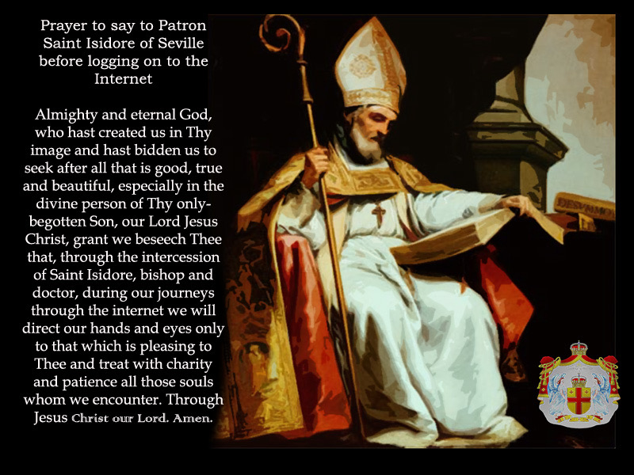
...and a fun, if anachronistic, little upgrade to St. Isidore’s picture...

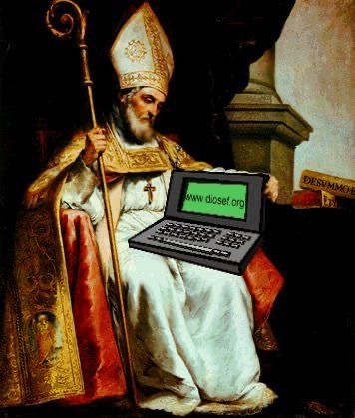

Have a great great week Celtics! Remember to reach out if you're struggling and to keep each other in your prayers! You are ALL in mine!! Stay safe, stay healthy, and stay strong!
And remember too, that this Thursday at noon we all take a break from school. No school Holy Thursday afternoon, or Good Friday, and no school Easter Monday. You've all done an amazing job - let this special Holy Week be a time of retreat, prayerful reflection, and rest.
Blessings!
Mrs. Brogan
--
Isabelle Brogan
Principal
Holy Trinity Catholic High School
"Start children off on the way they should go, and even when they are old they will not turn from it." ~ Proverbs 22:6

